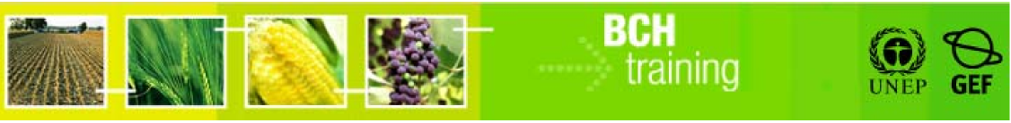

A User's Guide to the Central Portal of the Biosafety Clearing House

Recommended Guidelines for Countries to Interact with the Biosafety Clearing House

Module Outline

I. Abstract 3
II. List of Abbreviations 3
III. Introduction to the Module 4
1. Information Requirements for the BCH under the CPB 5
2. National Biosafety Framework Data & the BCH 3
3. Options for National Participation 8
  - Offline Access – Non internet/computer option 10
3.2. Option 1 – Registering information on the central portal using the Management Centre 14
3.3. Option 2 – Register data using database templates locally and send data to central portal 18
3.4. Option 3 – Make data available through a website and allow the central portal to retrieve it 22
3.5. Option 4 – Store data on national BCH and actively make those data available through the central portal using BCH interoperability standards 26
4. Donor Applications 30
4.1. Hermes Application by SCBD 30
4.2. Ajax Plug-in by SCBD 32
4.3. US nBCH Application 34
4.4. Canadian Application 37
4.5. Swiss Application 39
5. Some examples 41
5.1. Example 1 41
5.2. Example 2 43
5.3. Example 3 45
5.4. Example 4 46

I. Abstract

The report has been developed with the aim to provide an insight into the various options of the Biosafety Clearing House, and what possibilities are available for the parties to comply with their obligations under the Cartagena Protocol on Biosafety. It tries to map a relationship between the National Biosafety Framework and the Biosafety Clearing-House. There is a section on the various donor applications available for the countries with their benefits and disadvantages. Finally, there is a section with some examples of what sort of option(s) a country might choose given their circumstances and needs.

II. List of Abbreviations

AIA Advanced Information Agreement
BCH Biosafety Clearing-House
BCH-FP BCH Focal Point
CBD Convention on Biological Diversity
CMS Content Management System
COP Conference of Parties
CPB Cartagena Protocol on Biosafety
GEF Global Environment Facility
GMO Genetically Modified Organism
LMO Living Modified Organism
MC Management Centre
MOP Meeting of Parties
MoU Memorandum of Understanding
nBCH National BCH
NBF National Biosafety Framework
NFP National Focal Point
SCBD Secretariat of the Convention on Biological Diversity
SOAP Simple Object Access Protocol
UNEP United Nations Environment Programme
XML Extensible Markup Language

III. Introduction to the Module

The Cartagena Protocol on Biosafety makes provision under Article 20 for the establishment of a Biosafety Clearing-House and under Article 18, paragraph 3 of the Convention. The Biosafety Clearing House (BCH) is a central repository (portal) of information as stated under the protocol. The portal provides a common ‘ground’ for the exchange of information provided by the various parties.

The information found on the portal ranges from contact information, competent authorities of the countries to laws & regulations, procedures of the import of Genetically Modified Organisms/Living Modified Organisms (GMO/LMOs). This information is supplied by both the parties and non-parties to the protocol, and should conform to the requirements as defined under the protocol.

Since the information entered on the portal is supplied by a diverse set of users (parties and non-parties) and in order to allow countries to participate in the clearing house, various options are proposed and the countries are free to choose any and/or multiple options.

The countries might want to use an advanced option but in the interim (whilst the resources and systems are developed), in order to comply with their obligations, they could use a simpler one. For example, a country wants to use the Option 3 to submit information to the Central Portal but whilst the systems and infrastructure are developed use Option 1 to fulfill its obligations under the protocol.

This module aims to answer some of these questions and/or guide the reader to areas where more information can be found. The structure of the document or module is based as follows.

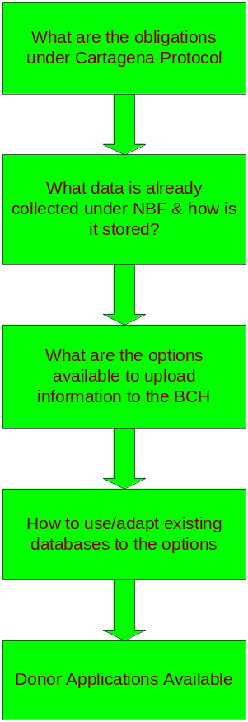

Figure 1 – Module Structure

There are sections which overlap with each other and it is not as sequential as shown in the flowchart and the reader is encouraged to refer to the other sections of the module.

There is also a section in the report which covers the ready-made applications which are available for the countries to use. These are standard applications with varying degrees of complexities and functionalities to be chosen by the countries depending on their requirements.

1. Information requirements for the BCH under the Cartagena Protocol

The Cartagena Protocol on Biosafety (CPB) requires the countries to make available certain types of information on the central portal. The clearing house mechanism, as specified under Article 18.3 of the convention has been established, details of its operation are listed under Article 20, Information-sharing and the Biosafety Clearing-House. Some of the requirements under the Protocol are listed below.

Extract information to be put on the BCH required by the CPB

- Any existing laws, regulations and guidelines for implementation of the Protocol, as well as information required by the Parties for the advance informed agreement procedure;

- Any bilateral, regional and multilateral agreements and arrangements;

- Summaries of its risk assessments or environmental reviews of living modified organisms generated by its regulatory process;

- Final decisions on the import or release LMOs;

For complete details, please refer to the Cartagena Protocol on Biosafety.

However, the COP/MOP may adopt other decisions in the future relating to the technical and operational aspects of the BCH. Thus the parties have to constantly monitor the new requirements (decisions) as and when they come in force to ensure that they comply with them as and when they come in force.

The Biosafety Clearing-House will need to be updated at the various stages of the project. For example, as soon as the Protocol enters into effect for the country, the Secretariat is informed of the country’s Competent National Authority (Authorities) which is then subsequently made available on the BCH.

The country will also make available on the BCH information when certain steps (activities) are taken. For example, if the party enters into any bilateral agreements then these will need to be communicated on the BCH. This applies to other articles of the protocol, namely, final decisions on the use of LMOs for food, feed or processing, decisions on Advanced Informed Agreement and so on.

Other types of information is only submitted to the BCH when certain events (triggers) occur, for example, if there is an illegal transboundary movement of LMOs then the BCH needs to be informed immediately. This applies to an unintentional release of LMOs under the jurisdiction of the country.

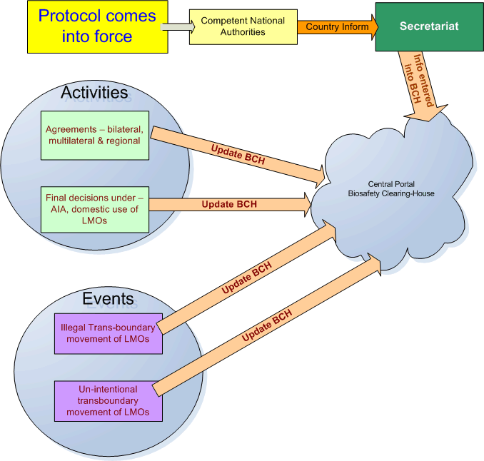

Figure 2 – CPB Activities Schematic

The BCH portal contains the following broad categories of information which the parties are required to enter into the BCH central portal:

- Existing national legislation, regulations and guidelines for implementing the Protocol, as well as information required by Parties for the advance informed agreement procedure (Article 20 paragraph 3 (a));

- National laws, regulations and guidelines applicable to the import of LMOs intended for direct use as food or feed, or for processing (Article 11 paragraph 5);

- Bilateral, multilateral and regional agreements and arrangements (Articles 14 paragraph 2 and 20 paragraph 3 (b));

- Contact details for competent national authorities (Articles 19.2 and 19.3);

- Contact details for national focal points (Articles 19 paragraph 1 and 19 paragraph 3);

- Contact details for emergency contact point for receiving notifications of unintentional transboundary movements of LMOs (Article 17 paragraph 2;

- Reports submitted by the Parties on the operation of the Protocol (Article 20 paragraph 3 (e));

- Decisions by a Party on regulating the transit of specific living modified organisms (LMOs) (Article 6 paragraph 1);

- Occurrence of unintentional transboundary movements that are likely to have significant adverse effects on biological diversity, and related information, including contact point for further information (Article 17 paragraphs 1 and 3);

- Illegal transboundary movements of LMOs (Article 25 paragraph 3);

- Final decisions regarding the importation or release of LMOs (i.e. approval or prohibition, any conditions, requests for further information, extensions granted, reasons for decision) (Article 10 paragraph 3 and Article 20 paragraph 3(d));

- Information on the application of domestic regulations to specific imports of LMOs (Article 14 paragraph 4);

- Final decisions regarding the domestic use of LMOs that may be subject to transboundary movement for direct use as food or feed, or for processing (Article 11 paragraph 1);

- Final decisions regarding the import of LMOs intended for direct use as food or feed, or for processing that are taken under domestic regulatory frameworks (Article 11 paragraph 4) or in accordance with annex III (Article 11 paragraph 6) (requirement of Article 20 paragraph 3(d));

- Declarations regarding the framework to be used for LMOs intended for direct use as food or feed, or for processing (Article 11 paragraph 6);

- Review and change of decisions regarding intentional transboundary movements of LMOs (Article 12 paragraph 1);

- LMOs subject to simplified procedures regarding intentional transboundary movement and exempted by a Party from the AIA procedure (Article 13, paragraph 1);

- Summaries of risk assessments or environmental reviews of LMOs generated by regulatory processes and relevant information regarding products thereof, namely, processed materials that are of living modified organism origin, containing detectable novel combinations of replicable genetic material obtained through the use of modern biotechnology; (Article 20 paragraph 3 (c)).

Information Categories Requirement of the BCH

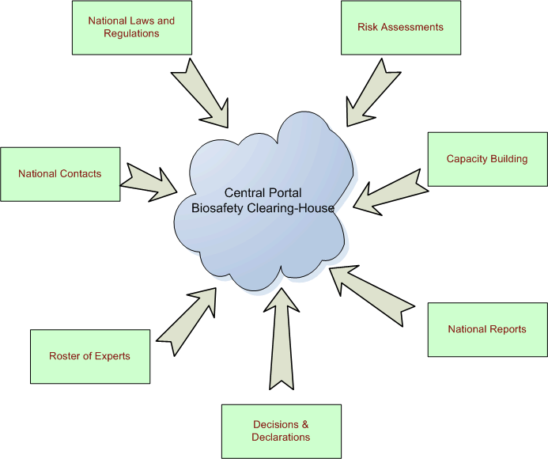

Figure 3

2. National Biosafety Framework Data & the BCH

The data requirements for the BCH have been mentioned in the previous chapter. During the development of the country’s National Biosafety Framework (NBF) a number of different kinds of data might have been collected. These would have been used under the different areas of the analysis and research carried out during the NBF process.

For example, the data on the national laws and regulations would already be researched and stored during the NBF process. During the NBF research and analysis was done in terms of the Biosafety Policy of the country and the Regulatory Regime. These can now be entered under the section of National Laws & Regulations on the BCH. The sections on the BCH of bilateral, multilateral and regional laws can be addressed from here.

The Administrative Framework identified the various institutions Competent Authorities allowing this to be entered under the section of National Contacts on the BCH.

During the course of analysis under Risk Assessment and Decision Making (NBF), summaries might have been generated and these can be transferred under the sections on Decision & Declarations and Risk Assessments on the BCH.

A schematic diagram of the data that can be mapped to the BCH is shown below.

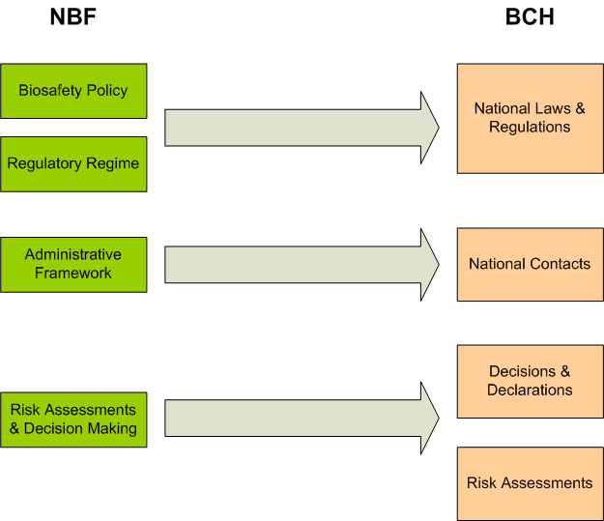

Figure 3 – NBF - BCH Information Mapping

During the development process of the NBF the country might have stored the different information (collected) in some electronic form. This could be a Microsoft Access database, Filemaker Pro or using some other database systems. This information can be used by the country to enter some of the information required for the BCH.

The information contained in the databases can usually be used by other systems using tools to extract and compile them in the required formats. A description of the options is given in the next section and also how this can be used with existing systems.

3. Options for participation with the BCH

The BCH functions like a “central information marketplace” where the users, providers of Biosafety information view and share information in a transparent manner. The access to the information is freely available while the submission of information is done via secure means. This access to the entry of information is restricted to designated users, BCH National Focal Points.

The parties to the Cartagena Protocol have various options available to them for submission of information to the Biosafety Clearing-House. Information regarding Decisions & Declarations, Advanced Information Agreements, Laws & Regulations, Risk Assessment and so on is submitted to the BCH and would require updates/modifications on a regular basis.

No one option is superior to the rest and the choice depends on various factors like the available infrastructure, manpower availability and so on. In this section, each of the option will be explained in detail with their benefits and limitations. The country also has the choice of switching from one option to the other as the options are not mutually exclusive.

All the options allow different ways for the countries to fulfill their obligations under the Cartagena Protocol on Biosafety by transferring information to the BCH database. Since different countries have various levels of Internet access both nationally and at department level the options have been designed to cater for the diverse needs.

Offline Access | Non-internet/computer option
Option 1 | Use the Management Centre
Option 2 | Use local database template and send information to central portal
Option 3 | Make data available through a local website and allow central portal to retrieve it
Option 4 | Store data on national BCH databases and make this information available to the central portal using agreed protocols

3.1 Offline Access – Non internet/computer option

When a country has limited Internet connectivity or in the case where the BCH-Focal Point (BCH-FP) and the National Authorized User (NAU) do not have an Internet connection, Secretariat of the Convention of Biological Diversity (SCBD) has forms which can be used to send information to the SCBD. The forms can be completed either by hand or by using a computer, if available, and duly approved by the BCH-FP.

The SCBD will enter this information on the central portal on behalf of the country.

Benefits

A country or party can still comply with its obligations under the CPB even though they do not have technical skills or facilities available.

Disadvantages

Totally manual system. All data is available, in online form on the BCH and locally on paper.

Offline Access – Process Layout

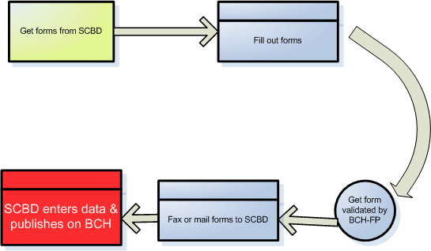

Figure 4

Summary

Reason for selecting this option | Method of sending information | Resources required | Cost implications
- Lack and/or un-reliable Internet facilities in the country.  - Lack of Internet facilities for BCH-FP and/or NAU. | - Get forms from SCBD.  - Complete forms, either manually or by computer  - Have the forms approved by BCH-FP.  - Send forms either by fax or mail. | None specified. | None apart from using a fax machine if sending by fax, otherwise postage costs.

How to send information?

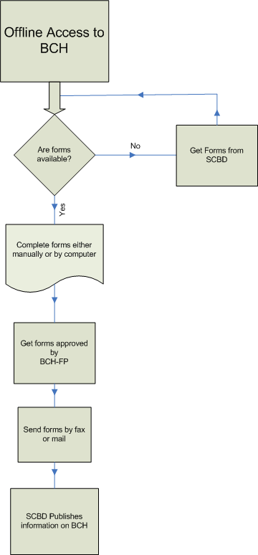

Figure 5

3.2. Option 1 – Registering information on the central portal using the Management Centre

If a country and/or BCH-FP have access to the Internet the party or Government can input information directly to the BCH by accessing an online system. This system is a website which is accessible by using a computer which has Internet access.

The data entry section of the BCH is known as the Management Centre, which acts as a central point of entry (console) to the BCH for editing, registering or deleting records. The Management Centre is a completely secure system controlled using usernames and passwords. This allows the government or party to register, delete, or edit its records using online data entry screens.

The SCBD will create a username/password for the BCH-FP who can enter, edit, or delete information, related to the country, on the BCH. This information will be published on the BCH as soon as the BCH-FP enters and saves it for publishing.

A useful facility is available, to countries using the Management Centre, to facilitate the entry of information. The BCH-FP has the option of creating National Authorized Users (NAU), who have limited access for registering information on the BCH. The NAU has access to the BCH for the purpose of creating records, but this information needs to be validated by the BCH-FP before it is published on the BCH.

There is no limit for the number of NAUs that can be created but there can be only one BCH-FP for a country. This allows for a central point of data validation for the country or party.

Benefits

- Parties or countries that do not have national websites can use this option to register information on the BCH to fulfill their obligations under the protocol.
- The country or party has total control on the information registered on the website, through a secure system of access.
- The information entered on the BCH, using the Management Centre, is available as soon as the BCH-FP validates it for publishing; minimizing any delays.
- The act of entering information can be delegated to the National Authorized Users (NAUs) who will enter the information on the BCH. The BCH-FP can simplify validate this information and publish it after verification.

Disadvantages

The data is available online only on the central BCH and not locally.

Management Centre – Process Layout

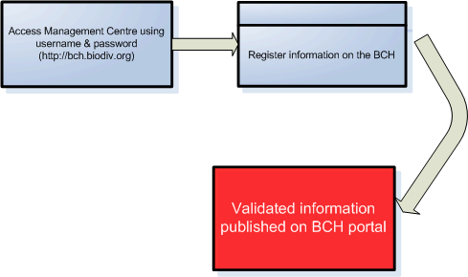

Figure 6
Summary

Reason for selecting this option | Method of sending information | Resources required | Cost implications
- Basic computer skills available. High level of technical capability not required.  - Internet facilities for BCH-FP available. | - Use the computer to access the Internet.  - Connect to the BCH website: http://bch.biodiv.org  - Log-in to the Management Centre using the username and password supplied by the SCBD.  - Access the online forms to enter the relevant information. e.g. National contacts, Decisions & Declarations and so on.  - Enter new information or edit old information.  - Save or publish the information. | Hardware:  - Computer system.  - Internet access, dial-up or more.  Software:  Internet explorer or Mozilla.  Note: This is generally supplied with the computer system.  Others  Basic computer skills to access the Internet. | Initial Cost:  - Computer System.  - Phone line for dial-up access.  Recurring cost:  - Monthly Internet Service provider fees.  - Monthly phone bills for dial-up access.

Note: The username/password supplied by the SCBD is for the BCH-FP. This user has complete access for registering information on the BCH. The BCH user can create additional users, National Authorized Users (NAU), who can register information on the BCH, through the Management Centre. However, this information needs to be validated by the National Focal Point (NFP) before it is published for public viewing. A valid email address is a requirement for the NFP as all confirmations/notifications are sent to this address.

How to register information?

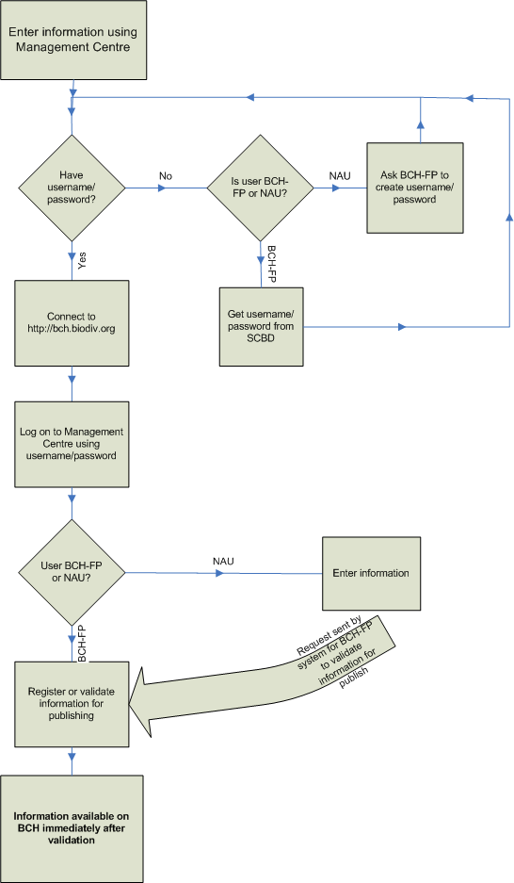
Figure 7

3.3 Option 2 – Register data using database templates locally and send data to central portal

Another option that a country or party can use to submit information to the BCH involves the storing of information, locally on computers in simple database, and using software to export this information directly into the BCH. This system stores the information in a similar structure as on the BCH and updates the BCH as and when desired the country or party.

The Secretariat has developed a set of templates, using the Microsoft Access software, which is available for the countries or parties to use. The software package is known as the Simple nBCH. The Simple nBCH can be installed on a computer running Microsoft Access and information entered on this system. Once the information is ready for transfer to the BCH, this can be done automatically by this software by one of 2 ways.

- The user connects to the Internet and transfers the records directly to the BCH. The Internet connection could either be a dial-up or dedicated connection (DSL/ADSL, Cable modem etc). This can be done every-time records are updated.

- In the case of poor Internet connectivity, the country or party can transfer/export the information on to a CD-ROM and dispatch this CD-ROM to SCBD. The SCBD would then upload this information upon receipt. The creation of the CD-ROM can be done periodically once a few records have been created and/or updated.

The Simple nBCH has been superseded by the donor application of the United States (see later) and this has added functionality and is available is multiple languages.

The country or party can also develop a system similar to the Simple nBCH using its own resources or modify the existing system to cater for its specific need and requirements. However, the system should conform to the requirements and specifications as required by the BCH to transfer information. It is recommended that the system be based on a relational database system such as Microsoft Access, Microsoft SQL, Oracle, Postgres or MySQL.

This system requires basic computer infrastructure and skills if the Simple nBCH software is used as is. If the country or party decides to adapt or develop their own system then more advanced skills will be required.

Benefits

- Data is stored locally in electronic form and updated on the BCH using standard technology. Therefore, the data is only entered once.

- If a country or party does not have reliable Internet facility, then the data can be sent by transferring on CD-ROM and mail. The SCBD will update the BCH upon receipt of CD-ROM.

Disadvantages

- When using the Simple nBCH, data needs to be entered into standard templates. It is only available locally on the computer where the data is entered. No public access.

- Reliance on SCBD or USA for constant updates and modifications.

- Advanced technical skills required for maintenance, modification or development of system.

Database Template - Process Layout

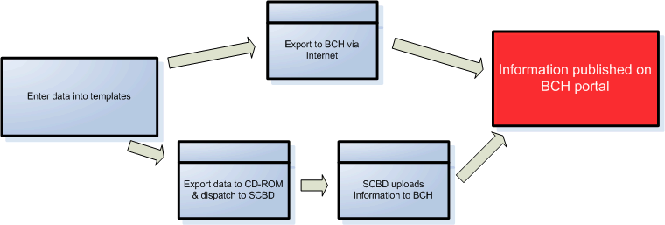

Figure 8
Summary

Reason for selecting this option | Method of sending information | Resources required | Cost implications
- Basic computer skills available, if using Simple nBCH.  - High level of technical capability required to adapt, modify or develop own system.  - Internet facilities for uploading information or blank CD-ROMs. | - Enter information on local computer in standard templates.  - Use the system to generate information for upload to BCH.  - If Internet facility available transfer updated/modified information to BCH via Internet.  - If no Internet available, generate CD-ROM in BCH compatible format and send to SCBD.  - Information published on BCH. | Hardware:  - Computer system.  - Internet access, dial-up or more or;  - CD Writer  - Blank CD-ROMs for generating records  Software:  - Microsoft Windows  - Microsoft Access  Others  Basic computer skills to advanced computers skills depending on option chosen. | Initial Cost:  - Computer System.  - Phone line for dial-up access.  - Human resource cost if developing  Recurring cost:  - Monthly Internet Service provider fees.  - Monthly phone bills for dial-up access.  - Blank CD-ROMs  - Human Resource person for maintenance and support.

Note: The method of validation or entry of data will have to be implemented by the country or party using this option. For example, one option could be, the BCH-FP can enter and upload the information. Another method could be that the information is entered on the local system by the NAU and the uploading is done by the BCH-FP after verification. This would allow for a system of check and control.
How to register information?

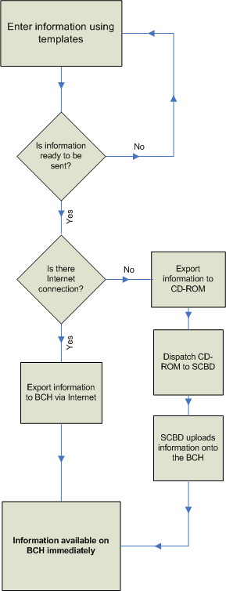

Figure 9
3.4 Option 3 – Make data available through a website and allow the central portal to retrieve it

If a country or party has or wants to have a local website containing Biosafety information then this information can be transferred directly to the BCH. The server, which hosts the local website, would store this information using standard internet exchange languages and the central BCH portal would retrieve (pull or crawl) this information on a regular basis and make it available on the BCH.

The data required for the BCH would need to be formatted in standard interchange languages (XML) to define the structure and content of the data. These are industry defined rules for the exchange of information between computer systems using common definitions. A complete technical document defining how and what information to send can be obtained from the SCBD.

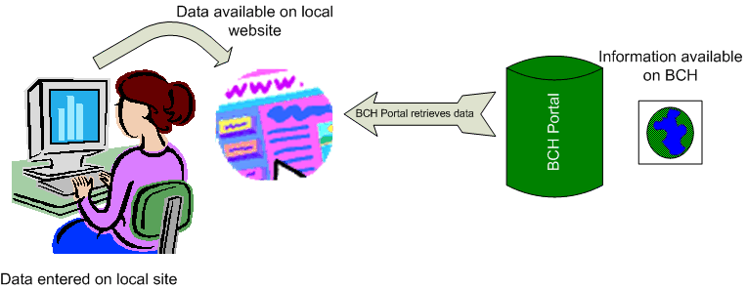Figure 10

Once the proper system for exchange of information is set up between the country or party and the BCH, the responsibility or when the actual transfer takes place, is determined by the BCH portal. Generally, this is once every 24-hours and therefore the maximum delay in the information being available on the central portal would be 24-hours.

This option is generally good for countries that have lots of information to make available to their local environment and/or who have to post information that might not be relevant to the BCH in addition to the CPB requirements. It is also useful for countries that already have a website and can make the information available to the BCH by doing some changes to the existing system.

The technical and human resource requirements for this option are quite high. A dedicated server is required to host the local website or nBCH, along with a dedicated high-speed permanent internet connection. In house technical competence for hosting, managing, development and maintenance of the website is required.

Benefits

- Data is available on local website and retrieved by the BCH formatted in the relevant format.

- The system provides regular updates and information is only entered once in the system.

- Information is available locally and allows the country or party to make available extra information that might be required by the laws/regulations of the country/party.

Disadvantages

- Advanced technical skills required for development of the system plus equipment and reliable high-speed internet.

- Data is updated once every 24-hours, therefore there can be a delay in the updates or information available on the BCH of 24-hours.

- The transfer of information to the BCH is dependent on the BCH and not the party or country.

- If there are any problems with the local BCH or internet then the information will not be updated on the BCH.

- The running cost of such a system both in terms of equipment maintenance and upgrades and, human resource skills is very high.

“Pull” Technology - Process Layout

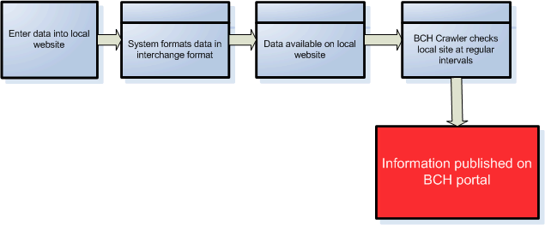

Figure 11

Summary

Reason for selecting this option | Method of sending information | Resources required | Cost implications
- Local website already available or;  - Country or party needs to make available information locally as well as to BCH.  - A lot of information needs to be entered or modified on a regular basis. | - Enter information on local computer/  website.  - System generates information for interchange with BCH.  - BCH “crawler” checks local website and uploads modified/created information to BCH.  - Information published on BCH. | Hardware:  - Web server hosting local website;  - High speed dedicated internet access;  Software:  Functionality to export information on server for BCH “crawler” to retrieve in approved formats.  Others  Advanced technical personnel for setting up and maintaining the system. | Initial Cost:  - Webserver  - Dedicated internet access facility.  - Human resource cost for developing the system.  Recurring cost:  - Monthly Internet Service provider fees.  - Upgrades to webserver and software.  - Human Resource person for maintenance and support.

How to register information?

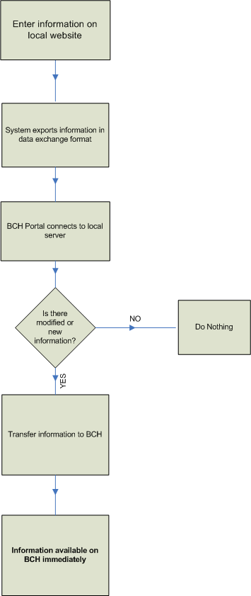

Figure 12

3.5. Option 4 – Store data on national BCH and actively make those data available through the central portal using BCH interoperability standards.

In this option, the country or party data is stored in national BCH databases, and made available or “pushed” to the central BCH. The local application sends information to the central BCH on an online basis. This requires a high speed and reliable internet connectivity on the part of the country or party so that the data will is available on the BCH as soon as an update is made on the national system.

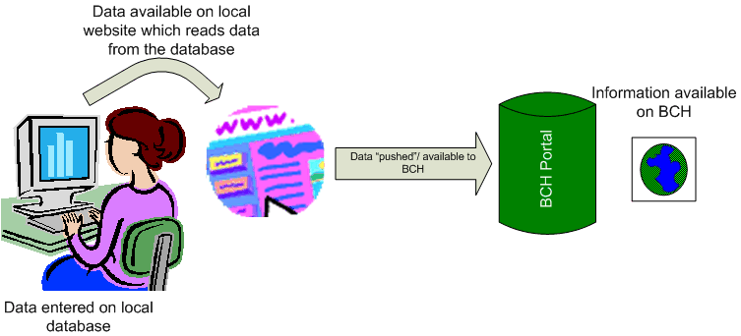
Figure 13

The national BCH will be based on a database system and using internet standards of interoperability will make the data available to the BCH. The interoperability standards define rules and structures for making data accessible by other web-based systems. The exchange of information takes place using secure means ensuring that there is no breach of information during transmission.

This option is highly technical and would require a great deal of resources both in terms of finance and human resources. The running cost of such a system would be high as it requires constant updates and maintenance in addition to good and reliable internet connectivity.

This option is recommended for countries or parties that might already have a website or database with the relevant information and would only require making the system inter-operable with the BCH. Also, the country or party that have a lot of information to make available including information that might not be necessarily required by the BCH could use this option. It could also be beneficial for a country that already has the resources in place to develop the inter-operability module and use this option.

Benefits

- Data is available on local website and transferred directly by the BCH.

- The information is maintained on the local website and entered only once.

- Information is available locally and allows the country or party to make available extra information that might be required by the laws/regulations of the country/party.

Disadvantages

- Advanced technical skills required for development of the system plus equipment and reliable high-speed internet.

- If there are any problems with the local BCH or internet then the information will not be updated on the BCH.

- Requires highly reliable and fast internet connectivity during the process of updating of the records on the BCH.

- The running cost of such a system both in terms of equipment maintenance and upgrades and, human resource skills is very high.

“Push” Technology - Process Layout

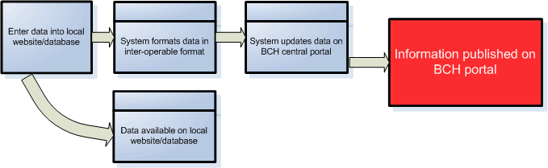

Figure 14

Summary

Reason for selecting this option | Method of sending information | Resources required | Cost implications
- Local website or database already available or;  - Country or party needs to make available information locally as well as to BCH.  - Lot information needs to be updated regularly.  - Human resource existing or available easily. | - Enter information on local computer/  website.  - System makes information available locally and inter-operable format for BCH.  - System updates/creates tags on BCH portal.  - Information published on BCH.  - BCH portal displays information directly from national databases when required. | Hardware:  - Web server hosting local website and database;  - High speed dedicated and reliable internet access;  Software:  System compatible in the inter-operable standards.  Others  Advanced technical personnel for setting up and maintaining the system. | Initial Cost:  - Webserver  - Dedicated internet access facility.  - Human resource cost for developing the system.  Recurring cost:  - Monthly Internet Service provider fees.  - Upgrades to webserver and software.  - Human Resource person for maintenance and support.

How to register information?

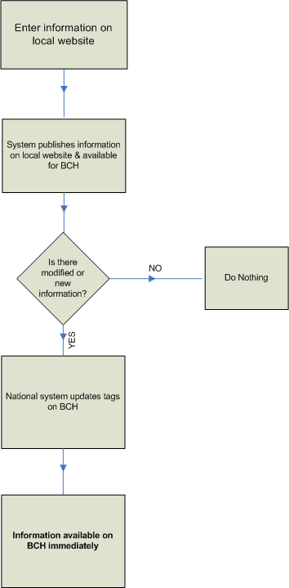

Figure 15

4. Donor Applications

Based on the options described in the previous section, the countries have available to them some donor applications. These applications have been created by the certain countries and are being made available for the countries to use on a voluntary and no-cost basis. Below is a summary of the applications available at the time of preparation of this report.

4.1 Hermes Application by SCBD

The SCBD has developed an online Content Management System to allow countries to create a portal for their National BCH. The system is offered by the SCBD and all the development, maintenance, updates and hosting is carried out by the Secretariat.

Data is entered via the Management Centre (Option 1) of the BCH Central Portal and the country utilizes the Hermes (CMS) to format the layout for the local website. The National System administrator will log-on to their Hermes website and customise their sections.

All the sections are fully-customizable allowing the country to upload their logos, banners, modify the colour schemes, menu layouts and so on. The system will be available for use in different languages.

Characteristics / Functionalities

- Easy to configure, add / remove sections, links, buttons, text and so on.

- Multilingual.

- Data entry through Management Centre and CMS used for the creation/modification of country nBCH.

Hardware & Software Requirements

- Internet access

- PC with web-browser

- No database software is needed

Benefits

- System developed and supported by the SCBD.

- Easy to install and operate.

- Does not require a local database, records are taken from the Central Portal.

- The BCH information is also available as national BCH website.

- One information entry point.

- The BCH Training already covers all the required skills to register the information and comply with the CP obligations.

- Low cost in money and human resources.

Disadvantages

- Information is hosted overseas.

- The local nBCH node of also hosted overseas.

SCBD Hermes Application - Process Layout

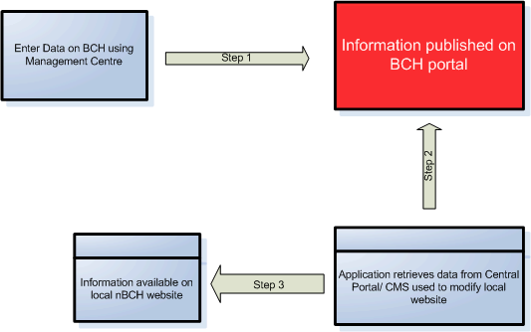

Figure 16

4.2 Ajax plug-in Application by SCBD

A simple JavaScript tool has been developed by the SCBD which can be easily integrated into any website to dynamically display the records. This is simple lines of code which retrieve the data from the BCH Portal and displays the results on the website. The use of this plug-in requires minimal IT knowledge and works on all server platforms.

This is especially useful for countries that have already developed a website and need to update the website to display the records that are on the BCH Central Portal.

Data is entered via the Management Centre (Option 1) of the BCH Central Portal and the country uses the Ajax plug-in to display the records on the National BCH website.

Sample Code:

<script type="text/javascript" charset="utf-8"
src="http://bch.biodiv.org/centralportal/ui/offsite/bch-offsite.js"></script>
<script type="text/javascript" charset="utf-8" >
GenerateRecords("focalPoint", "ca", "en");</script>

Figure 17

By inserting the above code, the focal points for Canada will be displayed on the web page. A complete list of documentation is available from the SCBD giving details of how to implement this code along the parameters required.

Characteristics / Functionalities

- Easy to implement by adding few lines of code

- Multilingual.

- Data entry through Management Centre and Ajax plug-in used to display the records on the nBCH.

Hardware & Software Requirements

- Internet access

- PC with web-browser

- No database software is needed

Benefits

- System developed and supported by the SCBD.

- Easy to implement and operate.

- Does not require a local database, records are taken from the Central Portal.

- The BCH information is also available on the national BCH website.

- One information entry point.

- Low cost in money and human resources.

Disadvantages

- Information is hosted overseas.

Ajax Plug-in - Process Layout

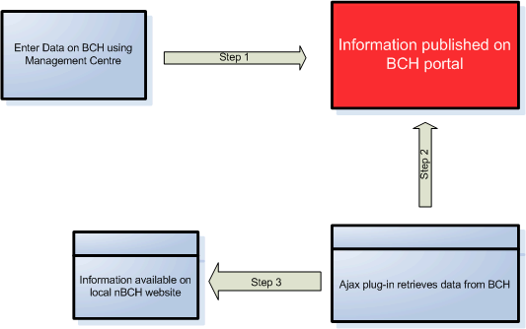

Figure 18

4.3 US Simple nBCH

The Secretariat of the Convention on Biological Diversity (SCBD) developed a simple National Biosafety Clearing-House Application (nBCH, section 3.3). The National Biological Information Infrastructure (US) then used this application as a building-block for a National database and a website template system. Using the experience gained during the development of the US nBCH, the US donor application was developed and functionalities added to the system.

It is fully compatible with the BCH Central Portal and contains templates for user input and development of a national website. It is available in English, Spanish, Russian and French for both the database storage and website templates.

The system can be used by countries that have no or limited Internet access to fast and reliable Internet access. It uses the Microsoft software platform and is suitable for countries with limited technical skills.

Some features of the system:

  - Can run locally (no Internet access required) or can connect to the BCH (Internet access required).

  - Data can be transferred to the BCH without any modifications.

  - Data entry is simple.

  - Lots of help available with the software.

  - Has website templates which are fully customizable to create national BCH and data uploaded on the BCH.

Hardware & Software Requirements

Simple installation of Database
(Minimum configuration)

- Personal computer

- Windows XP, Win2000, ME, or Win98

- Web browser software (for using help files and user documentation)

- Method of writing data to electronic media, or printing for facsimile transmission, or access to email

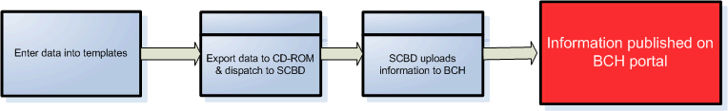

Figure 19

Full Installation of Database

- Minimum configuration (above)

- Basic Internet connection (Dial up) or

- Sustained Internet connection (Network)

- Simple Object Access Protocol (SOAP) client for connectivity with BCH (Installation instructions include in documentation)

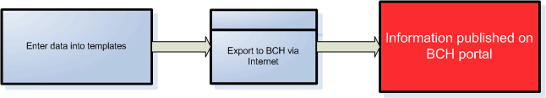

Figure 20

Installation of Website templates of Database

- Full Installation of database requirements, plus

- Web Server running Microsoft IIS

- HTML Editor to modify templates

US Application - Process Layout

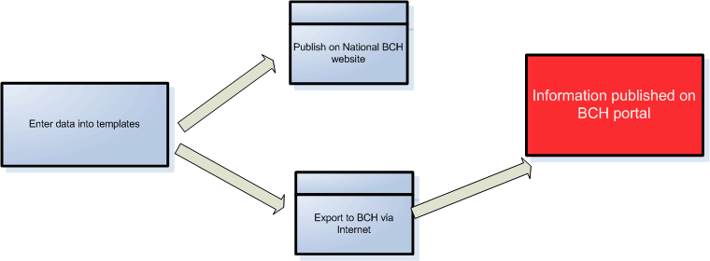

Figure 21

Apart from the benefits as mentioned under Section 3.3, this application allows for a local website to be created as well. However, it does require some technical skills for customization of the templates for websites.

The application can be downloaded using the following link: http://usbiotechreg.nbii.gov/download.asp

Benefits

- Easy to install and operate.

- Data stored locally.

- The BCH information is also available as national BCH website.

- One information entry point.

Disadvantages

- Requires minimum hardware and software for the option chosen.

- Internet access is required.

- Technical skills required to customise the templates for local website.

- Regular technical skill required for updates/modifications and backups.

- Support dependent on US government funding.

4.4 Canadian Application

The Canadian Government will make available a system which can be used by the countries. This system will be offered through the SCBD, where a computer server will be installed and national application instances configured. The countries will liaise with SCBD for creating their national applications on this server.

The system offers the functionality of entering information on the BCH using the Management Centre (Option 1) and an application then retrieves this information from the BCH, for the country, and displays on a local website.

This website (application) is hosted at the SCBD and any country can have this system set up for them. Access will be provided using secure username and password for the country to modify the appearance of the website, for example, to put their logos, color schemes etc. The customization of the system is very easy and only basic knowledge of web design is required.

Characteristics / Functionalities
- Easy to configure, add / remove sections, links, buttons, text and so on.

- Multilingual.

- Data entry through Management Centre and used for the creation of country nBCH.

Hardware & Software Requirements

- Internet access

- PC with web-browser

- No database software is needed
Benefits

- Easy to install and operate.

- Does not require a local database, records are taken from the Central Portal.

- The BCH information is also available as national BCH website.

- One information entry point.

- The BCH Training already covers all the required skills to register the information and comply with the CP obligations.

- Low cost in money and human resources.

Disadvantages

- Information is hosted overseas.

- The local nBCH node is also hosted overseas.

- Support dependent on Canadian government funding.

Canadian Application - Process Layout

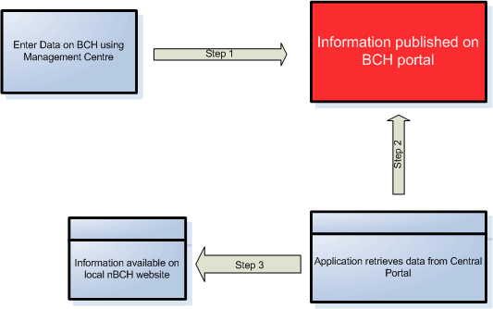
Figure 22

4.5 Swiss Application

A system is being made available by the Government of Switzerland to allow a country to participate in the BCH. The system will be hosted by the UNEP-GRID in Geneva and the country will have access to it via the Internet. User training will be provided at the time of the setting-up of the system and maintenance will be carried out by the Swiss government.

The system has been developed using open-source software and is fully-interoperable with the BCH using option 4 to “push” data onto the portal. The data can be entered by different users and different levels of access can be assigned to the users. A national BCH node is created for the country and information is submitted to the BCH Central Portal using option 4.

The system is multi-lingual and any number of languages can be set up.

Characteristics / Functionalities

- Configuration of system done at the start by Swiss government

- Multilingual.

- Multi-user data entry via web interface.

- Data uploaded to the BCH Central Portal.

Hardware & Software Requirements

- Internet access

- PC with web-browser

- No software is needed

Benefits

- Does not require a local database, records are taken from the Central Portal.

- The BCH information is also available as national BCH website.

- One information entry point.

- Training is provided during the set up stage.

- Low cost in money and human resources.

Disadvantages

- Information is hosted overseas.

- The local nBCH node is also hosted overseas.

- Support dependent on Swiss government funding.

Swiss Application - Process Layout

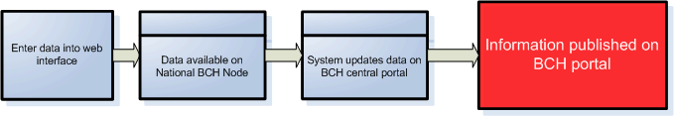

Figure 23

5. Some examples

The country can choose any or multiple options to enter the required data on the BCH.

5.1 Example 1

A country has not developed any local databases or applications but wants to comply with the obligation of the Protocol. The country has limited human resources and does not want to invest in major development of systems. The country can choose Option 1, data entry using the Management Center of the Central Portal. There are little training and human resource requirements for making this choice and the country is able to meet its obligations for participating in the Cartagena Protocol on Biosafety.

The process of uploading this information on the BCH would be as follows:

Figure 24

How to register information?

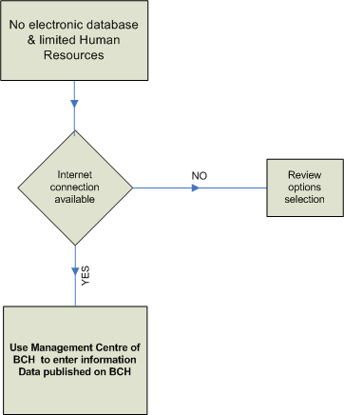

Figure 25

5.2 Example 2

The country does not have any electronic databases and has limited human resource facilities. The country wants to comply with its obligations under the protocol and would also require a local BCH website. The country can use Option 1, data entry using the Management Centre, and chooses the Hermes Content Management System to create its national BCH website.

This allows the country to enter its records at a single point and use the same data to create its national BCH portal. Minimal amount of training is required and support is provided by the SCBD.

The process for uploading the information and managing the national website will be as follows.

Figure 26
How to register information?

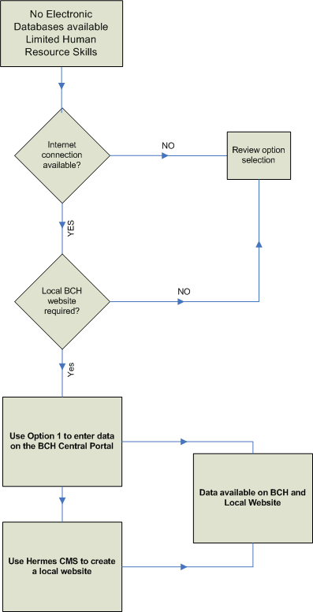

Figure 27

5.3 Example 3

The country has already developed a website for the national BCH. The country wants to comply with its obligations under the protocol and requires the information to be displayed on the national BCH website. The country can use Option 1, data entry using the Management Centre, and chooses the Ajax Plug-in to display the records on the national BCH website.

This allows the country to enter its records at a single point and use the same data on its national BCH portal. Minimal amount of training is required and support is provided by the SCBD.

Figure 28

5.4 Example 4

A country has developed a database in Microsoft Access (or File Maker Pro etc) and this stores information that is required on the BCH. The country has the option to create a simple module in Access that will create XML files which can subsequently be hosted on a web-server where the BCH crawler will “come” and collect this information and upload it on the BCH Central Portal. This would be using Option 3 to interact with the BCH.

The process of uploading this information on the BCH would be as follows:

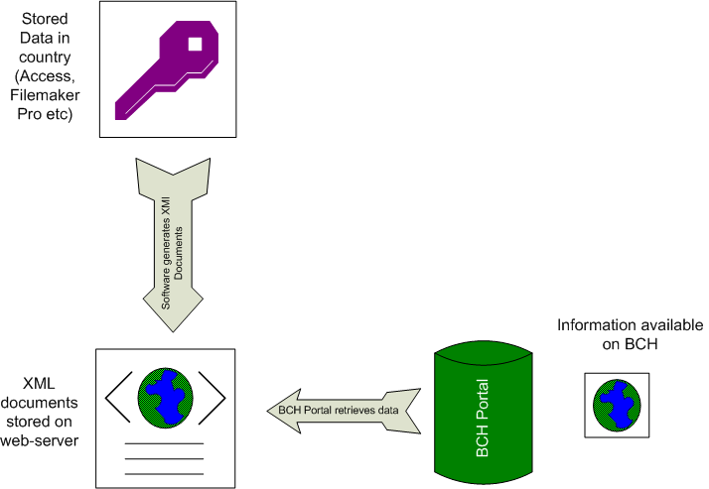

Figure 29

How to register information?

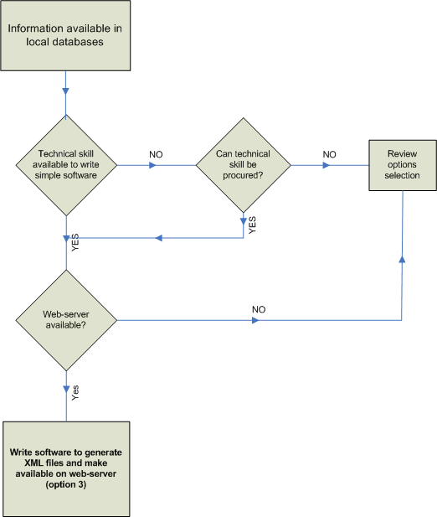

Figure 30

